 | www.STEAMatWork4Kids.org Career Curriculum
Lesson Title | Using a Venn Diagram to Explore Careers
Objective(s) | Students identify two or three careers that they find interesting. They put given career attributes into a Venn diagram to see what attributes they might want in a career, as well as which attributes they might want to steer away from.
Common Core Standards for Literacy in Science & Technical Subjects | CCSS.Math.Practice.MP4 Model with mathematics  Mathematically proficient students are able to identify important quantities in a practical situation and map their relationships using such tools as diagrams, two-way tables, graphs, flowcharts and formulas. They can analyze those relationships mathematically to draw conclusions.  CCSS.ELA-Literacy.RST.6-8.7  Integrate quantitative or technical information expressed in words in a text with a version of that information expressed visually (e.g., in a flowchart, diagram, model, graph, or table).
Materials | - Access to a computer or tablet to explore the STEAMatWork4Kids.org website  - “Venn Diagram Careers” worksheet (below). Younger students should find 2 careers and use the 2-circle Venn diagram. Older students should find 3 careers and use the 3-circle Venn diagram.
Procedure | Part I: Introduce the www.STEAMatWork4Kids.org website. Ask them to explore and find 2 or 3 careers that sound like something they might want to do.  Part II: Give students the 2-circle or 3-circle Venn diagram worksheet based upon how many careers they have chosen to explore. Ask them to look at the career attributes listed. Where do they fit in the Venn diagram? Can you think of other attributes not in the list? If so, add these to your Venn diagram.  Part III: Analyzing the Venn diagram. Which attributes were in both (or all three) of the careers? These are the attributes they should consider when thinking about possible career choices. Do some of the attributes lie outside the Venn diagram? Those might be things they would want to avoid when looking for a career. Were they surprised by any of their choices?  Ask them to circle the 3 most important attributes they would like in a career. Can they think of other careers that would have those attributes? If students come up with ideas of careers they would like to see in the website, contact sharon@steamatwork4kids.org to request that job be highlighted in a future post.
EXAMPLE of the worksheet | 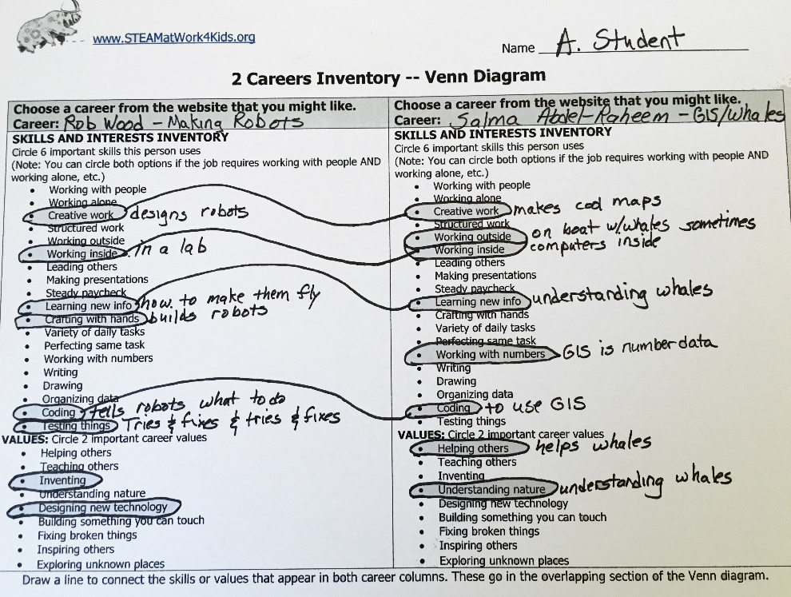  Here is an example where a student chose Rob Wood who makes robots and Salma Abdel-Raheem who follows whales using GIS.  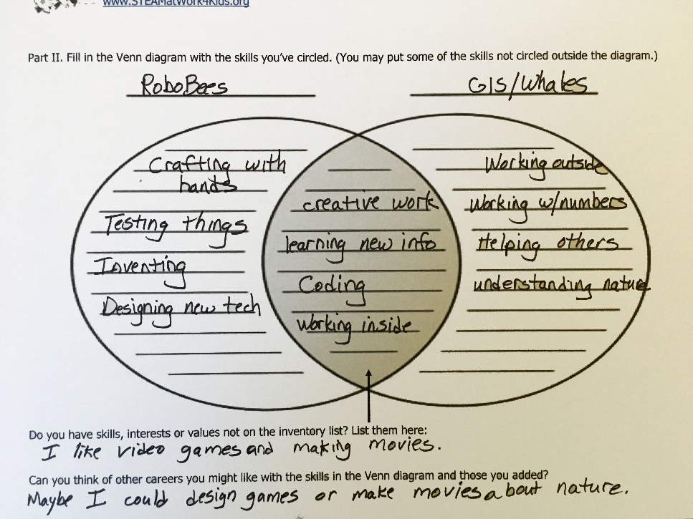  It is important to note that students have no real way of knowing what these people would circle if asked about their skills, interests, and values. The student can make educated guesses based upon the information in the interview and what they know. In fact, it makes the activity more relevant to the individual student because it’s a bit of a Rorschach Test. What the student chooses to see as important will reflect on what they themselves feel is important.  Only the brave will proceed to the 3-circle Venn diagram!
Name ______________________________
2 Careers Inventory -- Venn Diagram
Choose a career from the website that you might like.  Career: | Choose a career from the website that you might like.  Career:
SKILLS AND INTERESTS INVENTORY  Circle 6 important skills this person uses  (Note: You can circle both options if the job requires working with people AND working alone, etc.)  - Working with people  - Working alone  - Creative work  - Structured work  - Working outside  - Working inside  - Leading others  - Making presentations  - Steady paycheck  - Learning new info  - Crafting with hands  - Variety of daily tasks  - Perfecting same task  - Working with numbers  - Writing  - Drawing  - Organizing data  - Coding  - Testing things  VALUES: Circle 2 important career values  - Helping others  - Teaching others  - Inventing  - Understanding nature  - Designing new technology  - Building something you can touch  - Fixing broken things  - Inspiring others  - Exploring unknown places | SKILLS AND INTERESTS INVENTORY  Circle 6 important skills this person uses  (Note: You can circle both options if the job requires working with people AND working alone, etc.)  - Working with people  - Working alone  - Creative work  - Structured work  - Working outside  - Working inside  - Leading others  - Making presentations  - Steady paycheck  - Learning new info  - Crafting with hands  - Variety of daily tasks  - Perfecting same task  - Working with numbers  - Writing  - Drawing  - Organizing data  - Coding  - Testing things  VALUES: Circle 2 important career values  - Helping others  - Teaching others  - Inventing  - Understanding nature  - Designing new technology  - Building something you can touch  - Fixing broken things  - Inspiring others  - Exploring unknown places
Draw a line to connect the skills or values that appear in both career columns. These go in the overlapping section of the Venn diagram.

Part II. Fill in the Venn diagram with the skills you’ve circled. (You may put some of the skills not circled outside the diagram.)
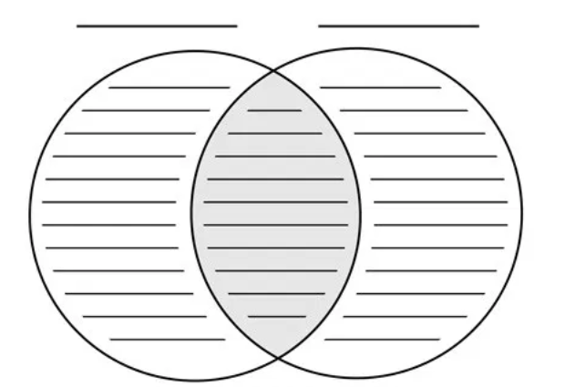
Do you have skills, interests or values not on the inventory list? List them here:

Can you think of other careers you might like with the skills in the Venn diagram and those you added?
Three Careers Inventory -- Venn Diagram
CAREER FROM THE WEBSITE: | CAREER FROM THE WEBSITE: | CAREER FROM THE WEBSITE:
SKILLS AND INTERESTS INVENTORY  Circle 6 important skills this person uses  (You can circle both options if the job requires working with people AND working alone, etc.)  - Working with people  - Working alone  - Creative work  - Structured work  - Working outside  - Working inside  - Leading others  - Making presentations  - Steady paycheck  - Learning new info  - Crafting with hands  - Variety of daily tasks  - Perfecting same task  - Working with numbers  - Writing  - Drawing  - Organizing data  - Coding  - Testing things  VALUES: Circle 2 important career values  - Helping others  - Teaching others  - Inventing  - Understanding nature  - Designing new technology  - Building something you can touch  - Fixing broken things  - Inspiring others  - Exploring unknown places | SKILLS AND INTERESTS INVENTORY  Circle 6 important skills this person uses  (You can circle both options if the job requires working with people AND working alone, etc.)  - Working with people  - Working alone  - Creative work  - Structured work  - Working outside  - Working inside  - Leading others  - Making presentations  - Steady paycheck  - Learning new info  - Crafting with hands  - Variety of daily tasks  - Perfecting same task  - Working with numbers  - Writing  - Drawing  - Organizing data  - Coding  - Testing things  VALUES: Circle 2 important career values  - Helping others  - Teaching others  - Inventing  - Understanding nature  - Designing new technology  - Building something you can touch  - Fixing broken things  - Inspiring others  - Exploring unknown places | SKILLS AND INTERESTS INVENTORY  Circle 6 important skills this person uses  (You can circle both options if the job requires working with people AND working alone, etc.)  - Working with people  - Working alone  - Creative work  - Structured work  - Working outside  - Working inside  - Leading others  - Making presentations  - Steady paycheck  - Learning new info  - Crafting with hands  - Variety of daily tasks  - Perfecting same task  - Working with numbers  - Writing  - Drawing  - Organizing data  - Coding  - Testing things  VALUES: Circle 2 important career values  - Helping others  - Teaching others  - Inventing  - Understanding nature  - Designing new technology  - Building something you can touch  - Fixing broken things  - Inspiring others  - Exploring unknown places

Part II – Building your Venn Diagram.
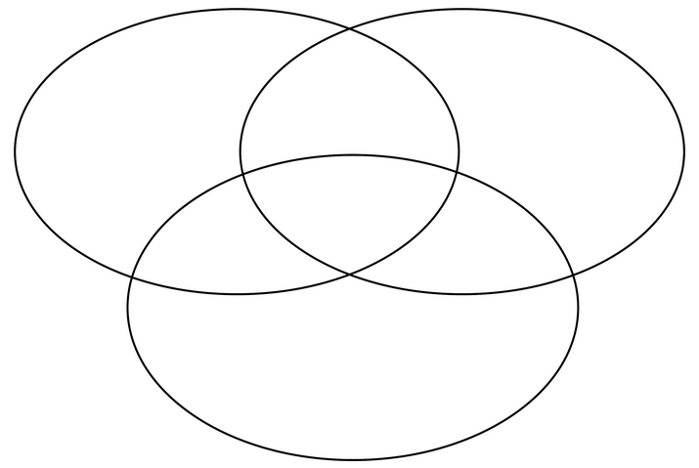
Do you have skills, interests or values not on the inventory list? List them here:

Can you think of other careers you might like with the skills in the Venn diagram and those you added?

